➢➢ Explanation :
- Consider that a block of N words is present.
- Now we have to arrange these N numbers in descending order, Let N = 4 for example.
- We will use HL as pointer to point the block of N numbers.
- Initially in the first iteration we compare the first number with the second number. If first number > second number don’t interchange the contents. If first number < second number swap their contents. Now at the end of this iteration first two elements are sorted in descending order.
- In the next iteration we will compare the first number along with third. If first > third don’t interchange contents otherwise swap the contents. At the end of this iteration first three elements are sorted in descending order. Go on comparing till all the elements are arranged in descending order. This method requires approximately n comparisons.
➢➢ Algorithm :
Step I : Initialize the number of elements counter.
Step II : Initialize the number of comparisons counter.
Step III : Compare the elements.
If first element > second element goto step VIII else goto step V.
Step IV : Swap the elements.
Step V : Decrement the comparison counter.
Step VI : Is count = 0 ? If yes, goto step VIII else goto step IV.
Step VII : Insert the number in proper position.
Step VIII : Increment the elements counter.
Step IX : Is count = N ? If yes, goto step XI else goto step II.
Step X : Stop.
➢➢ Flowchart : Refer flowchart 18.
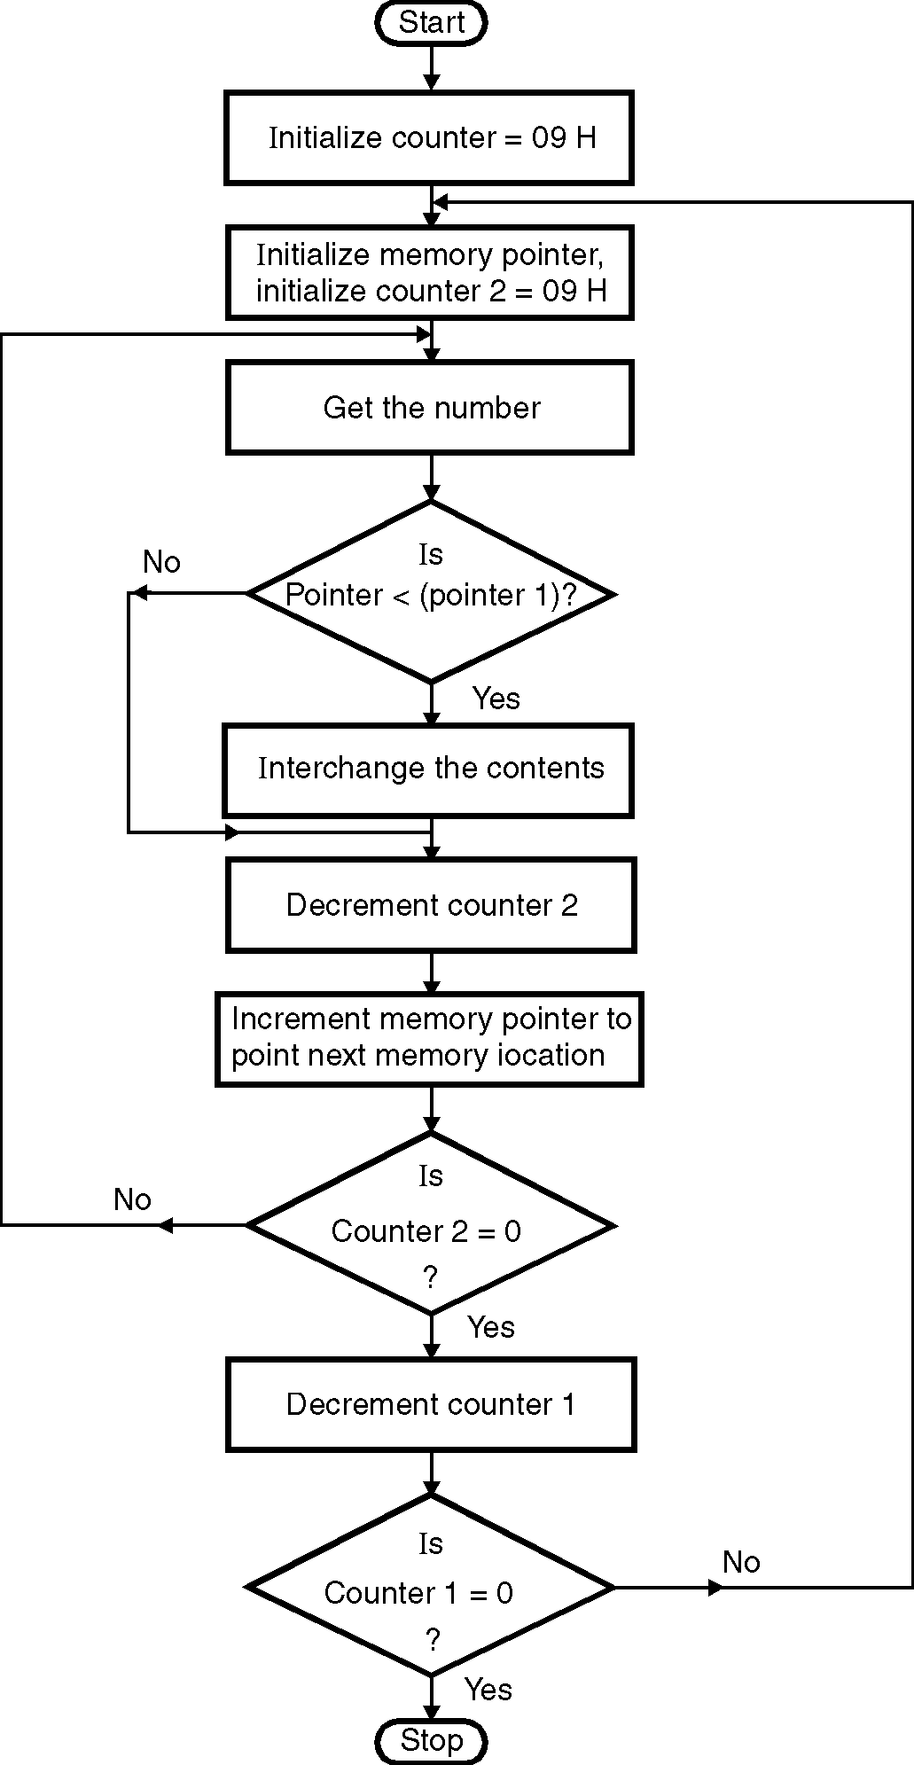
Flowchart 18
➢➢ Program :
Instruction Comment
MVI B, 09 ; Initialize counter 1
START : LXI H, D000H ; Initialize memory pointer
MVI C, 09H ; Initialize counter 2
BACK : MOV A, M ; Get the number in accumulator
INX H ; Increment memory pointer
CMP M ; Compare number with next number
JNC SKIP ; If more, don’t interchange
JZ SKIP ; If equal, don’t interchange
MOV D, M ; Otherwise swap the contents
MOV M, A
DCX H ; Interchange numbers
MOV M, D
INX H ; Increment pointer to next memory location
SKIP: DCR C ; Decrement counter 2
JNZ BACK ; If not zero, repeat
DCR B ; Decrement counter 1
JNZ START ; If not zero, repeat
HLT ; Terminate program execution

